Top Book Restful Java

**Best Books to Learn Web Services in Java**[[1]](#footnote-1)

[**1) Java Web Services: Up and Running by Martin Kalin**](https://www.amazon.com/Java-Web-Services-Practical-Introduction/dp/1449365116?tag=javamysqlanta-20)

This should be the first book you read to get a hand of what is soap and rest web services, what can you do with them, and how to implement them with JAX-WS and JAX-RS. If you are entirely new to this topic, I recommend writing some of the code examples the book gives, and if you already have some knowledge, you can just go through the book skipping the parts that you consider you already know well enough.  
  
The second edition provides you more RESTful context than the first version as REST has come a long way in recent years to become the first choice web service technology. This is also an excellent book to prepare for Oracle Certified Java expert for Web services (OCEJWSD) certification, exam code 1Z0-897.  
  
You can also see [**REST Java Web Services by Udemy**](https://click.linksynergy.com/fs-bin/click?id=JVFxdTr9V80&subid=0&offerid=323058.1&type=10&tmpid=14538&RD_PARM1=https%3A%2F%2Fwww.udemy.com%2Frest-web-services-using-java-ee%2F) to learn about Web Services in Java. It's an excellent course to combine with this book.

[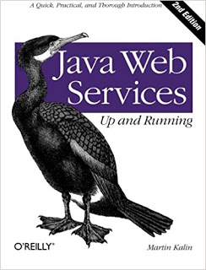](https://www.amazon.com/Java-Web-Services-Practical-Introduction/dp/1449365116?tag=javamysqlanta-20)

[**2) RESTful Java with JAX-RS 2.0 by Bill Burke**](http://www.amazon.com/RESTful-Java-JAX-RS-Bill-Burke/dp/144936134X?tag=javamysqlanta-20)

If you have some knowledge of Java and OOP and you want to learn how to developer REST based clients and servers, then this is the right book for you. It covered JAX-RS 2.0 specification from Java EE 7 and focused on implementation rather than theory.  
  
You will learn how REST and JAX-RS work together and when to use them. It uses JBoss' [RESTEasy](http://javarevisited.blogspot.sg/2017/02/difference-between-jax-rs-restlet-jersey-apache-cfx-RESTEasy.html) framework to demonstrate JAX-RS 2.0 features with several hands-on examples.  
  
It also teaches you a little bit advanced concepts like securing REST and popular mechanisms to perform authentication on the Web, including client-side SSL and OAuth 2.0 and HTTP Content Negotiation, caching, etc.  
  
It's actually a complete guide to developing REST web services using Java platform, particularly JAX-RS 2.0, useful for both beginners and experienced. Alternatively, if you want to use Jersey, then you can check **[RESTFul Services in Java using Jersey](https://pluralsight.pxf.io/c/1193463/424552/7490?u=https%3A%2F%2Fwww.pluralsight.com%2Fcourses%2Frestful-services-java-using-jersey" \t "_blank)** course on Udemy. It's a very hands-on course to develop the REST application in Java using Jersey.

[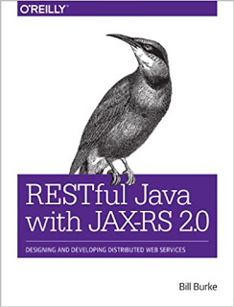](http://javarevisited.blogspot.sg/2015/08/difference-between-soap-and-restfull-webservice-java.html)

[**3) RESTful Web Services by Leonard Richardson**](http://www.amazon.com/RESTful-Web-Services-Leonard-Richardson/dp/0596529260?tag=javamysqlanta-20)

This is actually the best book on RESTful Web Services, collectively authored by Leonard Richardson and Sam Ruby. Unlike the previous book, which is a guide to implementing REST web services in Java using JAX-RS 2.0, this is the guide for [RESTful web services](http://www.java67.com/2015/09/top-10-restful-web-service-interview-questions-answers.html) itself.  
  
Even David Heinemeier Hansson, the creator of the Rails framework, who has also forward this book, has said that "Every developer working with the Web needs to read this book." and I couldn't agree more.  
  
You will learn every single detail about web services and that too from the web perspective. You will learn what URI is, how [HTTP](http://javarevisited.blogspot.sg/2016/04/what-is-purpose-of-http-request-types-in-RESTful-web-service.html) can be used as application-level protocol, and not just a transport protocol to transfer data between client and server.

[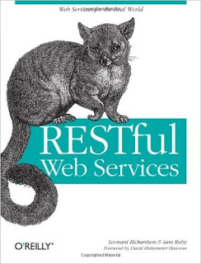](http://javarevisited.blogspot.sg/2016/05/what-are-idempotent-and-safe-methods-of-HTTP-and-REST.html)

You will also learn Resource oriented architecture and, most importantly, how a RESTFul design is more straightforward, more versatile, and more scalable than an RPC based web service design. In short, a great book to learn everything about REST web services from a web developer perspective.

[**4) Spring REST**](https://www.amazon.com/Spring-REST-Balaji-Varanasi/dp/1484208242/?tag=javamysqlanta-20)

This book explains all the details of developing RESTful web services using Spring Framework. For example, Spring provides [RestTemplate](http://javarevisited.blogspot.sg/2017/02/how-to-consume-json-from-restful-web-services-Spring-RESTTemplate-Example.html) to only the consumption of RESTful web services. You can connect to a REST service using this class and process response in JSON, XML, and TEXT format. Spring framework is full of such helpful classes and utilities.  
  
If you want to use Spring for creating RESTful APIs, I also suggest you take a look at [**REST with Spring by Eugen Paraschiv**](http://www.baeldung.com/rest-with-spring-course?utm_source=javarevisited&utm_medium=web&utm_campaign=rws&affcode=22136_bkwjs9xa), it's one of the best resources for Java developers.

[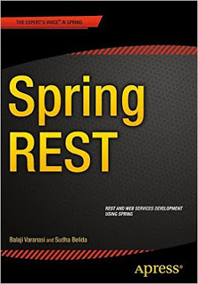](https://click.linksynergy.com/fs-bin/click?id=JVFxdTr9V80&subid=0&offerid=323058.1&type=10&tmpid=14538&RD_PARM1=https%3A%2F%2Fwww.udemy.com%2Frest-web-services-using-java-ee%2F)

That's all in this list of **great books to learn web services in Java**. It includes papers on both SOAP and RESTful web services. The knowledge of SOAP and REST web services will give you a big plus in your resume because not many developers know how web services actually work or how to apply best practices, be it SOAP or REST. Since the current trend is towards RESTful web service, learning a little bit more about REST is even more beneficial.

1. https://www.java67.com/2017/04/3-great-books-to-learn-java-web-services-soap-and-restful.html [↑](#footnote-ref-1)